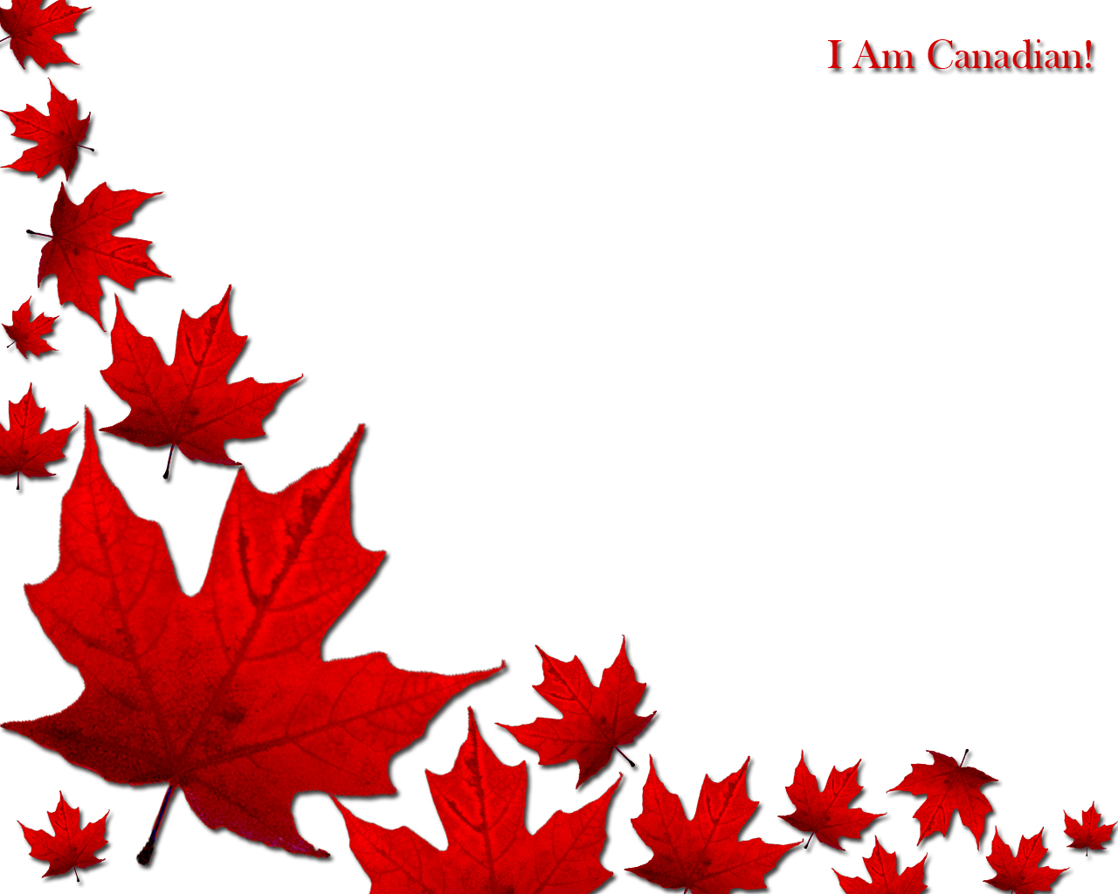

I am Canadian by Ashley

I am a fourteen year old girl living in Winnipeg Manitoba. I like to play volleyball and soccer, even though they are not our national sports. I feel as though I am, in some ways stereotypical because I am super polite and always apologizing.

I am the daughter of a military man and a stay at home mom with an accounting degree. Growing up with a father in the military has helped me to appreciate what we have been given. We have freedom, clean air, fresh water and food. Men and women have given and continue to give their lives daily for Canadians and others to live life in peace, and to do or become whatever they want. (Within reason of course)

In a way my family represents the diversity of Canada. My dad’s side of the family has red hair and green eyes. While my mom’s side of the family has brown/black/blonde hair and brown/blue eyes.  Canada has a population of 35.16 million and growing, but no one is the same. People from around the world come here to live. My family has 92 people in it and counting. We are all different, even my identical twin cousins. No one is, or ever will be the same in families or in this country. Our families and the individuals in them are all puzzle pieces, different designs, and different features. Every time someone new comes into our puzzle it expands to fit them in. Our country welcomes thousands of people from around the world each year and every time someone new comes we fit them in. Some way, somehow, we all have our place. We just have to find where we belong, in the enormous, diverse, ever-growing puzzle we call Canada.

Who am I in Canada? I am but a puzzle piece. Trying to find its place. Just like most people in our country, our families, our school, and our lives.

Who am I in Canada? I am but a puzzle piece. Trying to find its place. Just like most people in our country, our families, our school, and our lives.